References:

<https://www.anomali.com/resources/what-is-a-tip>

MODEL

* Infrastructure architecture
* Features
* Program – python
* Database
* Log info

Application 🡺

* Graph
* Testing
* Monitoring
* Detection
* Info gather

Dataset 🡺

Files, sites,

Tools and features =

* Monitor analytics
* Threat detection
* Network info

Formats of data =

Csv, json, xml, txt, pdf, doc,

Threat intelligence platform works with log managements and SIEM.

Security product/service integrations:

* SIEM
* ENDPOINT
* FIREWALL
* API
* IPS (intrusion prevention system)
* SOAR

AI THREAT INTELLIGENCE PLATFORM

An AI threat intelligence platform project is a project to develop a software system that uses artificial intelligence (AI) to collect, process, analyze, and disseminate threat intelligence data. AI threat intelligence platforms can help organizations to:

* Identify new threats more quickly and easily: AI can be used to process large volumes of threat intelligence data and identify patterns and correlations that would be difficult or impossible for humans to identify on their own. This can help organizations to identify new threats more quickly and easily.
* Prioritize threats more effectively: AI can be used to assess the risk posed by different threats and prioritize them accordingly. This can help organizations to focus their resources on the threats that are most likely to impact them.
* Automate threat response: AI can be used to automate many of the tasks involved in responding to threats, such as investigating incidents and deploying remediation strategies. This can help organizations to respond to threats more quickly and effectively.

Project Process

The process for developing an AI threat intelligence platform project can be divided into the following stages:

* Requirements gathering: This stage involves identifying the organization's security goals, objectives, and risk profile. This information will be used to define the scope and goals of the AI threat intelligence platform project.
* Design: This stage involves designing the architecture and functionality of the AI threat intelligence platform. This includes identifying the data sources that will be used, the AI algorithms that will be used to process and analyze the data, and the methods that will be used to disseminate the threat intelligence.
* Development: This stage involves developing the AI threat intelligence platform. This includes writing the code, implementing the AI algorithms, and integrating the different components of the platform.
* Testing: This stage involves testing the AI threat intelligence platform to ensure that it meets the organization's requirements and that it is secure and reliable.
* Deployment: This stage involves deploying the AI threat intelligence platform to production. This includes installing the platform on the organization's network and configuring it to work with the organization's existing security systems.

Tools and Technologies

A variety of tools and technologies can be used to develop an AI threat intelligence platform. Some popular tools and technologies include:

* Programming languages: Python and R are popular programming languages for machine learning and data science.
* Machine learning frameworks: TensorFlow, PyTorch, and scikit-learn are popular machine learning frameworks that can be used to develop AI threat intelligence algorithms.
* Threat intelligence platforms: There are a number of commercial and open-source threat intelligence platforms available that can be used to develop an AI threat intelligence platform.

Conclusion

AI threat intelligence platforms can be a valuable tool for organizations that are looking to improve their security posture. By using AI to process and analyze threat intelligence data, organizations can identify new threats more quickly and easily, prioritize threats more effectively, and automate threat response.

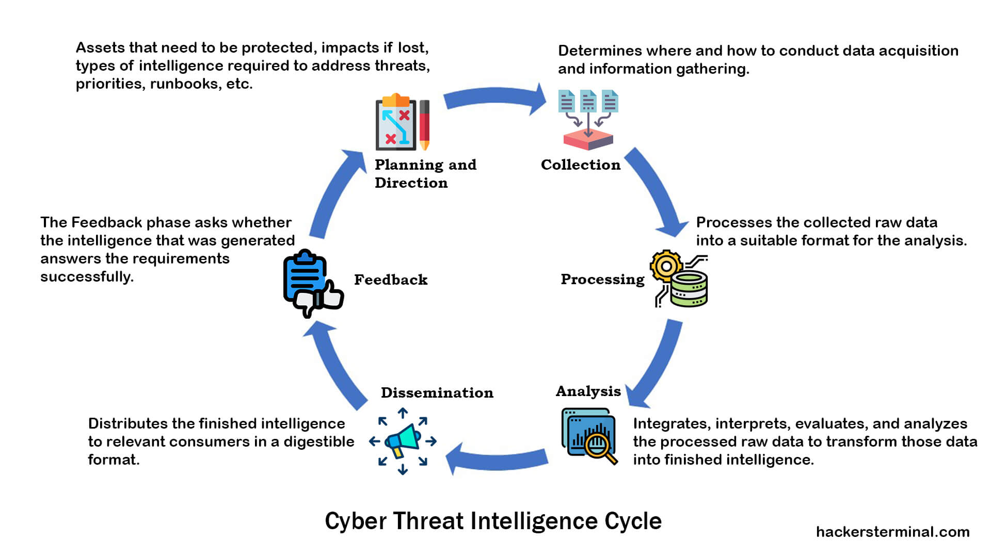

DATA FLOW DIAGRAM

[Data Sources]

-> [AI Threat Intelligence Platform]

-> [Data Processing]

-> [AI Analysis]

-> [Threat Intelligence]

-> [Dissemination]

-> [Stakeholders]

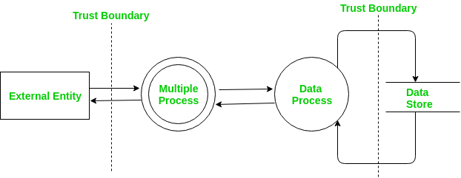

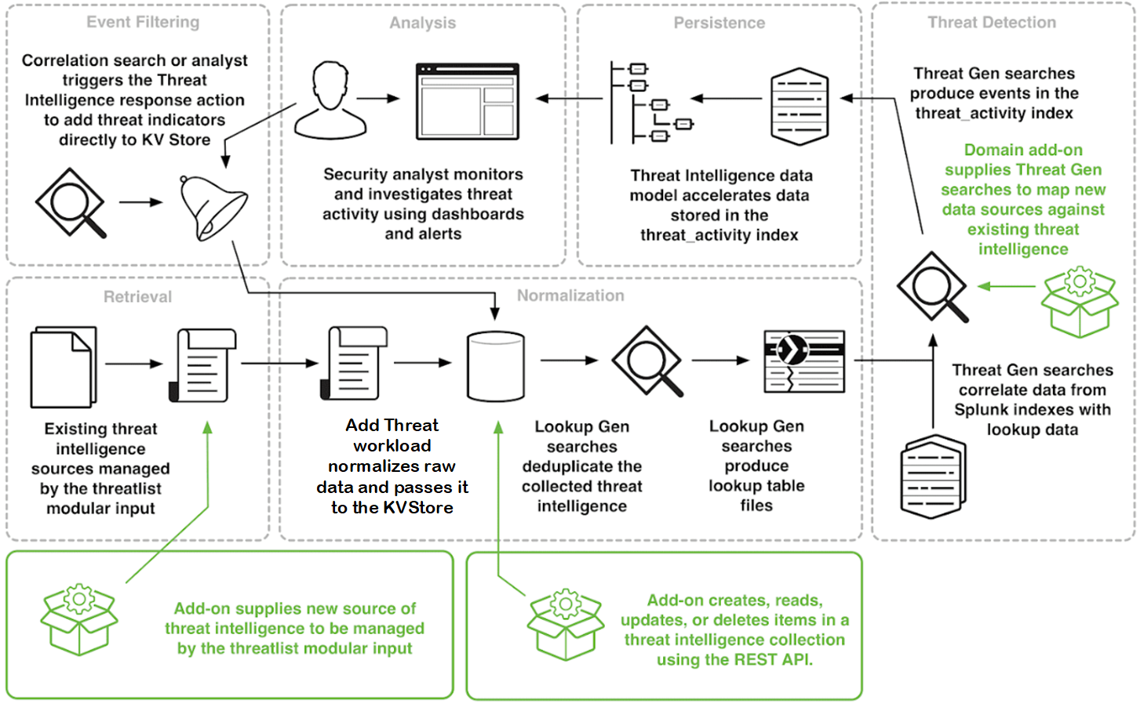

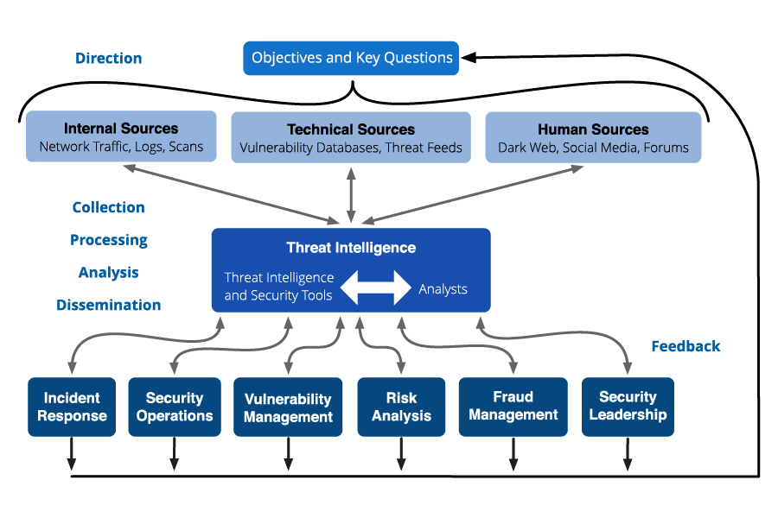

**Data Sources**

The data sources for an AI threat intelligence platform can include:

* Internal security systems, such as firewalls, intrusion detection systems, and security information and event management (SIEM) systems
* Open-source intelligence (OSINT) sources, such as social media, news websites, and security blogs.
* Commercial threat feeds

**AI Threat Intelligence Platform**

The AI threat intelligence platform is the central component of the system. It is responsible for collecting, processing, analyzing, and disseminating threat intelligence data.

**Data Processing**

The data processing component of the AI threat intelligence platform is responsible for cleaning, normalizing, and enriching the collected threat intelligence data. This may involve identifying relationships between different pieces of data, extracting key insights, and assessing the credibility of the data.

**AI Analysis**

The AI analysis component of the AI threat intelligence platform is responsible for analyzing the processed threat intelligence data to identify trends, patterns, and new threats. Analysts may also use the data to develop threat profiles of specific threat actors.

**Threat Intelligence**

The threat intelligence component of the AI threat intelligence platform is responsible for storing and managing the analyzed threat intelligence data. It may also provide tools for analysts to generate reports and briefings.

**Dissemination**

The dissemination component of the AI threat intelligence platform is responsible for sharing the analyzed threat intelligence with the appropriate stakeholders within the organization. This may be done through reports, briefings, or by integrating the data with other security systems.

**Stakeholders**

The stakeholders for an AI threat intelligence platform can include:

* Security analysts
* Incident responders
* Risk managers
* Business executives

The data flow diagram shows how the different components of the AI threat intelligence platform interact with each other. The data flows from the data sources to the AI threat intelligence platform, where it is processed, analyzed, and disseminated to the stakeholders.

Proposed solution

Problem statement 🡺

The challenge of rapidly evolving cybersecurity threats necessitates the development of an AI-based Threat Intelligence Platform. This platform will employ advanced machine learning to proactively detect and predict emerging threats, automate threat analysis, provide actionable insights, seamlessly integrate with existing security infrastructure, and continuously adapt to evolving threat landscapes. It will feature a user-friendly interface, align with compliance standards, and ensure scalability while addressing privacy and ethical concerns. The project aims to offer organizations an effective, adaptable, and cost-efficient solution for staying ahead of cyber threats and protecting their digital assets.

Idea 🡺

Develop an AI-based Threat Intelligence Platform to revolutionize threat detection and response. Leveraging advanced machine learning, it proactively identifies emerging cyber threats, prioritizes them, and integrates with existing security tools, providing actionable insights for swift responses. The platform adapts to evolving threats while maintaining compliance and scalability, ensuring cost-effective, intelligent security.

Uniqueness 🡺

Proactive AI: The platform uses advanced machine learning to proactively predict threats, going beyond traditional reactive solutions.

Intelligent Automation: It streamlines threat analysis, categorizes threats, and provides actionable insights, reducing response times.

Social impact 🡺

The project's social impact is multifaceted: it bolsters cybersecurity, protecting individuals and organizations from data breaches and cyberattacks. It also supports privacy and ethical considerations, spurs job creation, and offers educational opportunities in cybersecurity, while contributing to global security by mitigating the impact of cybercrime on society.

Business model 🡺

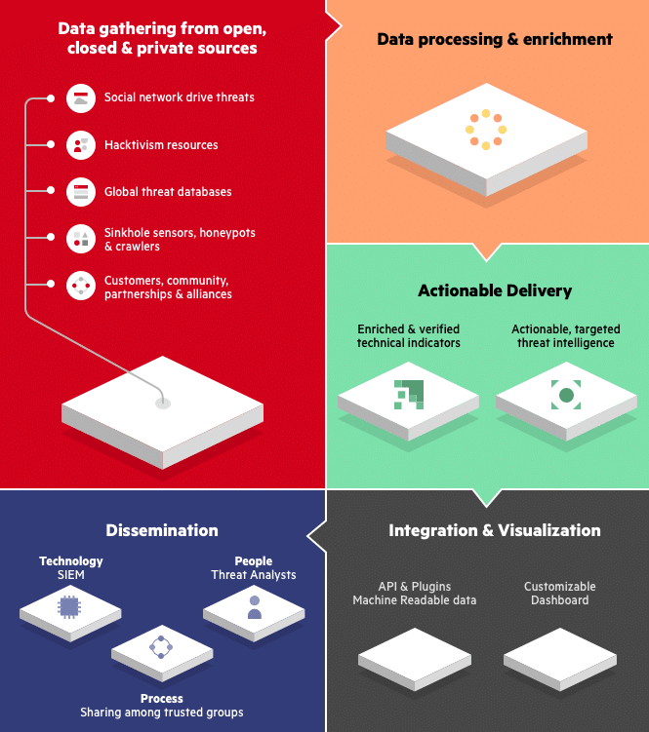

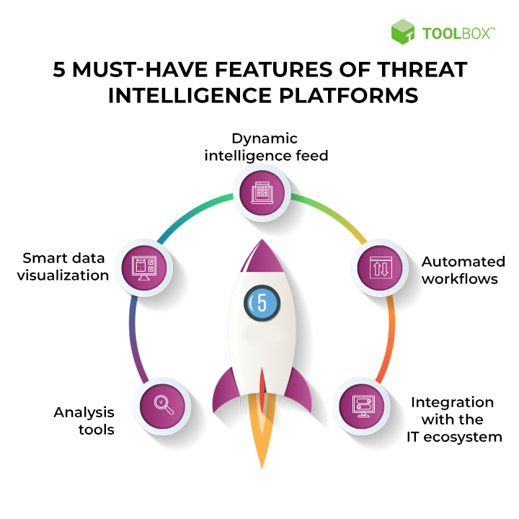

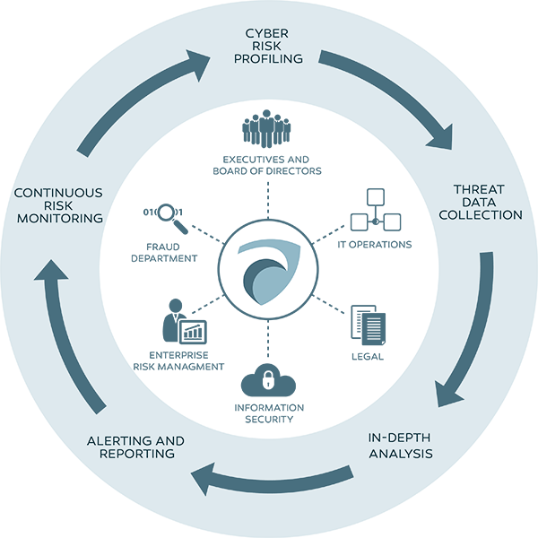

Scalability 🡺

The scalability of the AI-based Threat Intelligence Platform is a key feature. It's designed to handle the increasing volume and complexity of threat data as organizations grow, making it suitable for both small and large enterprises. Scalability is achieved through cloud-based solutions, flexible architecture, and efficient data storage and processing techniques. This ensures that the platform remains effective and accessible as the threat landscape evolves and organizations expand.